Create the K8s EKS,further you have to do the deployment of the Nginx application and access the application outside the cluster

Created the EKS Cluster and deployed the nginx
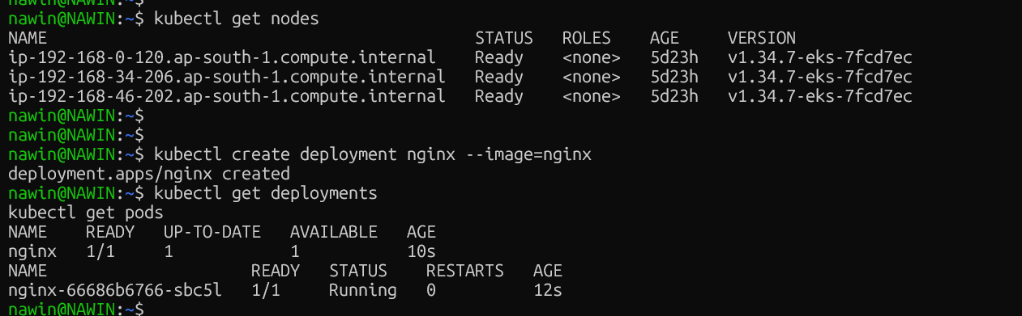
Expose Nginx Outside the Cluster

NGINX STATUS
